DC power supply

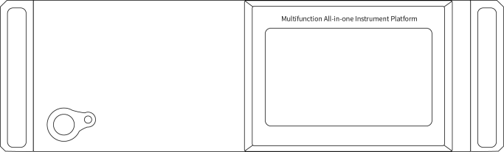

UM-10 Channel Series Module Power Product Manual

catalogue
DC power supply - 1 -
Security Summary 1
Chapter I Overview 2
1.1 Functional features 2
1.2 Front and back panels 2
1.2.1 Power switch 3
1.2.2 Power Status Indicator 3
1.2.3 Touch screen 3
1.2.4 Back Panel 6
Chapter II Description of Operation 8
2.1 Constant voltage output 8
2.2 Constant current output 9
Chapter Ⅲ Performance index 11
3.1 Voltage and current output 11
3.2 Setting Resolution 11
3.3 Setting accuracy: 12
3.4 Ripple 12
3.5 Line regulation & Load regulation 13
3.6 OVP\OCP 13
3.7 Operating Environment 14
3.8 Storage environment 14
3.9 Power Input 14
3.10 Accessories 14
3.11 Product Size 14
3.12 Weight 14
Chapter Ⅳ Product Toxic and Harmful Substances Statement 15
Chapter Ⅴ Warranty Service 17

Note: The performance indicators are subject to change without statement.

Security Summary
This chapter contains important safety instructions that must be followed to operate the power supply and storage environment. To ensure your personal safety, please read the following operating instructions before operation to ensure that the power supply is in the best working environment.
Safety Guide
General Introduction 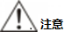 | - Do not place heavy objects on the case.
 | - Avoid damage to the machine due to severe impact or improper handling.
 | - Take precautions against electrostatic discharge when connecting the instrument.
 | - Do not block or isolate the fan vents.
 | - Do not open the machine unless it is a professional.
Power Supply | - AC input voltage: 220V ± 10%,50Hz or 110V ± 10%,60Hz (customized)
Power Supply | - The ground wire of the power cord needs to be connected to the ground terminal to avoid electric shock.
cleaning machine 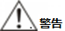 | - Cut off the power before cleaning.
 | - Use mild detergent and water to wet a soft cloth, do not spray detergent directly.
 | - Do not use chemicals or cleaning agents containing abrasive products such as benzene, toluene, xylene and acetone.
Operating Environment | - Place of use: indoor, avoid direct sun, dust and strong magnetic field.
Operating Environment | - Relative humidity: ≤ 80%
Operating Environment | - Altitude:<2000m
Operating Environment | - Temperature: 0 ℃ to 40 ℃
Storage Environment | - Location: Indoor
Storage Environment | - Relative humidity: ≤ 70%
Storage Environment | - Temperature:-20 ℃ ~ 80 ℃

Chapter I Overview
This series of products is the 1 integrated maximum of 10 groups of module power supply programmable DC regulated current power supply, touch screen display, while displaying 10 module power output voltage, current, power value.

  - Functional features
- 7 inch touch screen display power output voltage, current, power at the same time.
- Constant voltage and constant current are automatically switched.
- Support 10 output channels, can be independent or synchronous output.
- Over voltage, over current, over power, over temperature, short circuit five protection function.
- In the output off state, the voltage value and the current value can be preset, and the operation is convenient.
- MODBUS RTU protocol support, standard USB, RS232, RS485 three kinds of communication interface.
- The temperature control fan makes the instrument have low noise and the fan life is longer.

  - Front and back panels

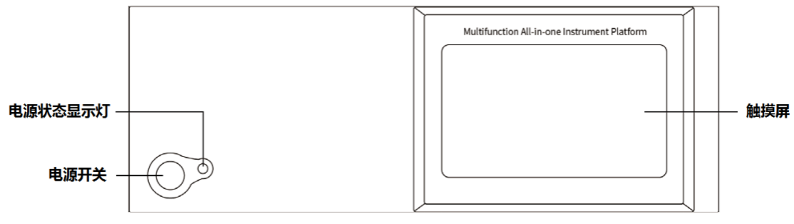
Touch screen
Power status
indicator
Power switch
Front Panel

    - Power switch
Used to turn the power on or off, the pressed state is on.
    - Power Status Indicator
Press the power switch. Turn on the power, the power status display light shows a green state; turn off the power, the display light goes out.
    - Touch screen
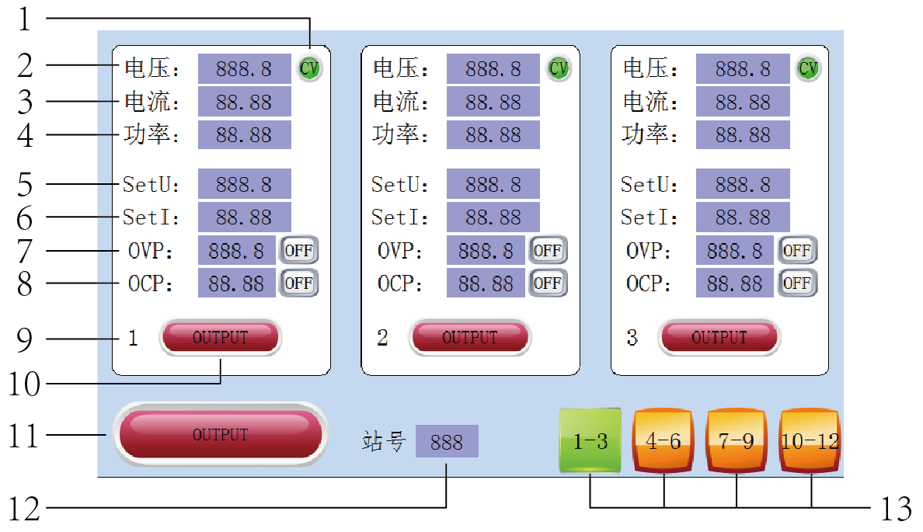
"1-3" "4-6" "7-9" channel display interface
- Output mode: CV is the constant voltage output mode, and CC is the constant current output mode. Refer to 2.1 and 2.2.
- "Voltage" is the actual output voltage value display window, unit:(V).
- "Current" is the actual output current value display window, unit:(A).
- "Power" is the actual output power display window, power value = voltage value * current value, unit:(W).
- "SetU": voltage preset window, unit:(V), click the preset value, can be changed.
- "SetI" is the current preset window, unit:(A), click the preset value to change it.
- "OVP" is the over-voltage protection setting window. The value on the left is the over-voltage protection threshold. If the actual output voltage exceeds this value, the output will be automatically turned off. Click the value to change it. The string on the right is the switch state of over-voltage protection, "OFF" is to turn off the protection, and "ON" is to turn on the protection. Click the string to switch.
- "OCP" is the over-current protection setting window. The value on the left is the over-current protection threshold. If the actual output current exceeds this value, the output will be automatically turned off. Click the value to change it. The string on the right is the switch state of over-current protection, "OFF" is to turn off the protection, and "ON" is to turn on the protection. Click the string to switch.
- Number of channel window: "1"-"10" channel window corresponds to 10 output channels on the back panel, and the corresponding window can set the preset voltage, preset current, OVP, OCP, and output state of the channel.
10 "OUTPUT" independent on/off switch: Independently control the output state of the corresponding channel, click to switch, the green output state is on, and the red output state is off.
11 "On and off main switch": It can control the output state of 10 switches at the same time. Green indicates that the output status of at least one channel is on; red indicates that the output status of all channels is off.
12 "Station Number": The power supply's address can be found in the 10-12 channelSettings within go to change.
13 "1-3", "4-6", "7-9", "10-12" pass through the channel display menu: Indicates that each 3 group of channels is an interface. Click to switch different channel interfaces and perform different channel output control settings.
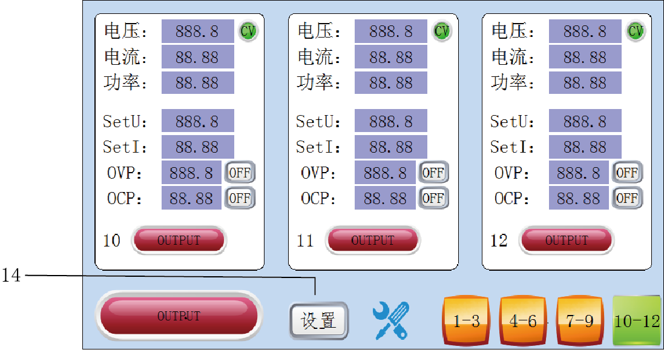
"10-12" channel display interface
14 "Settings": located at the "10-12" channel interface, click in to set the station number, baud rate, touch calibration, screen saver time, backlight brightness.
Note: "" button appears on the prohibition icon,Indicates that the feature is locked.

    - Back Panel
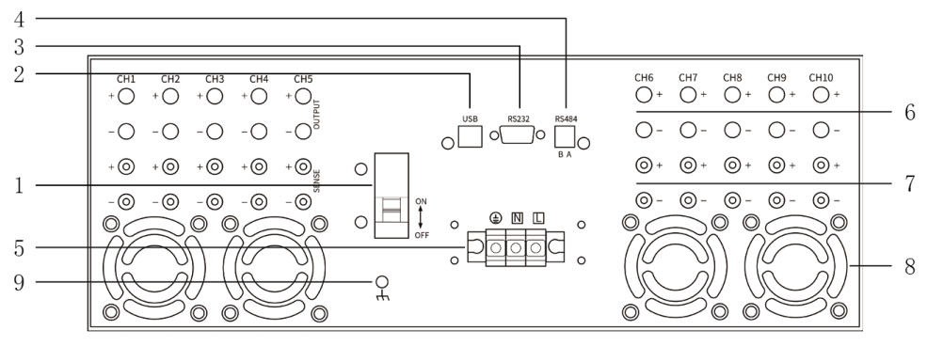
Rear panel drawing

- Circuit breaker: overload will trip protection.
- USB serial port support: USB serial communication.
- RS232 serial port support: RS232 serial port communication.
- RS485 serial port support: RS485 serial port communication.
- Power input: AC input interface, three lines of fire, zero and ground.
- OUTPUT output terminal terminal: from left to right corresponding to 1 to 10 output channels, red is the output positive pole (+), black is the output negative pole (-).
- Sense Compensation ( this feature is only supported on a wide range of models): From left to right, the compensation corresponds to 1 to 10. Interface, Red is the compensation positive pole (+), and black is the compensation negative pole (-). This function is optional.
- Fan air guide: used for internal heat dissipation.
9 Grounding terminal: ground safety terminal.

Note: USB, RS232, RS485 interfaces support MODBUS RTU communication protocol.

Chapter II Description of Operation
  - Constant voltage output
Each channel power supply provides two power output modes: constant output (CV) and constant output (CC). Output off state can be preset voltage value, current value, CV mode, the output voltage value for the power supply setting voltage value; CC mode, the output current value for the power supply setting current value;
Take channel 1(CH1) as an example: the voltage of CH1 is set to 16V, the current is set to the maximum rating, and the input load is 8Ω/300W. 16V/8Ω = 2A < maximum rated value, so the constant voltage output is 16V, 2A power supply.
Operation steps:
- Connect the output lead: Connect the CH1 output terminal to the load as shown in the following figure.
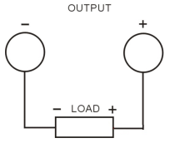
- Turn on the power: press the power key to start the instrument, and each channel enters the state to be output ("OUTPUT" key is red).
- Voltage setting: Press CH1's voltage key to set the voltage value to 16V.
- Current setting: Press CH1's current "current" key to set the current value to the maximum rating.
- Turn on the output: press CH1's "OUTPUT" key (the corresponding channel OUTPUT key is green), the channel works in the regulated output mode.

Tip: In CV mode, if the output current exceeds the set value due to load changes, the instrument will automatically switch to CC mode and the output voltage will be reduced proportionally. In this case, the CV output can be recovered by increasing the current setting value.
  - Constant current output
For example, the CH1 voltage is set to 16V, the current is set to 5A, and the connected load is1Ω/300W. Since 1Ω×5A = 5V < 16V, and 16V/1Ω = 16A > 5A, CH1 constant current outputs 5V and 5A.
Operation steps:
- Connect the output lead: Connect the CH1 output terminal to the load as shown in the following figure.
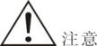Incorrect connection may cause damage to the product or equipment connected to the product.
- Turn on the power: press the power key to start the instrument, and each channel enters the state to be output (the "OUTPUT" key is red).
- Voltage setting: Press CH1's voltage key to set the voltage value to 16V.
- Current setting: Press CH1's current "Current" key to set the current value to 5A.
- Turn on the output: press CH1's "OUTPUT" key (corresponding to the channel OUTPUT bright green), the channel works in constant current output mode.

Tip: In CC mode, if the output voltage exceeds the set value due to load changes, the instrument will switch to CV mode, and the output current will decrease proportionally. At this time, the voltage set value can be increased to restore the CC output.

Chapter Ⅲ Performance index
When using this specification, please make sure to boot for more than 10 seconds.

  - Voltage and current output
Type | Output voltage | Output current | Output power
15V2A Module | 0V ~ 15V | 0A ~ 2A | 0 ~ 30W
15V5A Module | 0V ~ 15V | 0A ~ 5A | 0 ~ 75W
15V20A Module | 0V ~ 15V | 0A ~ 20A | 0 ~ 300W
30V5A Module | 0V ~ 30V | 0A ~ 5A | 0 ~ 150W
30V10A Module | 0V ~ 30V | 0A ~ 10A | 0 ~ 300W
60V5A Module | 0V ~ 60V | 0A ~ 5A | 0 ~ 300W
100V3A Module | 0V ~ 100V | 0A ~ 3A | 0 ~ 300W
150V2A Module | 0V ~ 150V | 0A ~ 2A | 0 ~ 300W
40V20A Module | 0V ~ 40V | 0A ~ 20A | 0 ~ 300W
80V10A Module | 0V ~ 80V | 0A ~ 10A | 0 ~ 300W
160V5A Module | 0V ~ 160V | 0A ~ 5A | 0 ~ 300W
  - Setting Resolution
Type | Voltage setting resolution | Current setting resolution
15V2A Module | 10mV | 1mA
15V5A Module | 10mV | 1mA
15V20A Module | 10mV | ＜10A: 1mA  ≥10A: 10mA
30V5A Module | 10mV | 1mA
30V10A Module | 10mV | ＜10A: 1mA  ≥10A: 10mA
60V5A Module | 10mV | 1mA
100V3A Module | ＜100V: 10mV  ≥100V: 0.1V | 1mA
150V2A Module | ＜100V: 10mV  ≥100V: 0.1V | 1mA
40V20A Module | 10mV | 10mA
80V10A Module | 10mV | <10A: 1mA  &ge; 10A: 10mA
160V5A Module | 100mV | 1mA

  - Setting accuracy:
Type | Voltage setting accuracy | Current setting accuracy
15V2A Module | ≤0.1%+5digits | ≤0.2%+10digits
15V5A Module | ≤0.1%+5digits | ≤0.2%+10digits
15V20A Module | ≤0.1%+5digits | ≤0.2%+10digits
30V5A Module | ≤0.1%+5digits | ≤0.2%+10digits
30V10A Module | ≤0.1%+5digits | ≤0.2%+10digits
60V5A Module | ≤0.1%+5digits | ≤0.2%+10digits
100V3A Module | ≤0.1%+5digits | ≤0.2%+10digits
150V2A Module | ≤0.1%+5digits | ≤0.2%+10digits
40V20A Module | ≤0.1%+5digits | ≤0.2%+10digits
80V10A Module | ≤0.1%+5digits | ≤0.2%+10digits
160V5A Module | ≤0.1%+5digits | ≤0.2%+10digits

  - Ripple
Type | voltage ripple | current ripple
15V2A Module | ≤10mVrms | ≤10mArms
15V5A Module | ≤10mVrms | ≤10mArms
15V20A Module | ≤10mVrms | ≤10mArms
30V5A Module | ≤10mVrms | ≤10mArms
30V10A Module | ≤10mVrms | ≤10mArms
60V5A Module | ≤15mVrms | ≤15mArms
100V3A Module | ≤18mVrms | ≤18mArms
150V2A Module | ≤20mVrms | ≤20mArms
40V20A Module | ≤12mVrms | ≤18mArms
80V10A Module | ≤12mVrms | ≤18mArms
160V5A Module | ≤12mVrms | ≤26mArms

  - Line regulation & Load regulation
Type | Line regulation | Load regulation
15V2A Module | ≤0.1%Umax+5mV | ≤0.1%Umax+5mV
15V5A Module | ≤0.1%Umax+5mV | ≤0.1%Umax+5mV
15V20A Module | ≤0.2%Umax+5mV | ≤0.2%Umax+5mV
30V5A Module | ≤0.1%Umax+5mV | ≤0.1%Umax+5mV
30V10A Module | ≤0.2%Umax+5mV | ≤0.2%Umax+5mV
60V5A Module | ≤0.2%Umax+5mV | ≤0.1%Umax+5mV
100V3A Module | ≤0.2%Umax+5mV | ≤0.1%Umax+5mV
150V2A Module | ≤0.2%Umax+5mV | ≤0.1%Umax+5mV
40V20A Module | ≤0.2%Umax+5mV | ≤0.2%Umax+5mV
80V10A Module | ≤0.2%Umax+5mV | ≤0.2%Umax+5mV
160V5A Module | ≤0.2%Umax+5mV | ≤0.2%Umax+5mV

  - OVP\OCP
Type | Overpressure protection threshold | Overcurrent protection threshold
15V2A Module | 0V ~ 16V | 0A ~ 2.1A
15V5A Module | 0V ~ 16V | 0A ~ 5.1A
15V20A Module | 0V ~ 17V | 0A ~ 20.5A
30V5A Module | 0V ~ 33V | 0A ~ 5.5A
30V10A Module | 0V ~ 33V | 0A ~ 10.5A
60V5A Module | 0V ~ 65V | 0A ~ 5.5A
100V3A Module | 0V ~ 103V | 0A ~ 3.5A
150V2A Module | 0V ~ 153V | 0A ~ 2.5A
40V20A Module | 0V ~ 41V | 0A ~ 20.5A
80V10A Module | 0V ~ 81V | 0A ~ 10.5A
160V5A Module | 0V ~ 161V | 0A ~ 5.5A

  - Operating Environment
Indoor use
Altitude: ≤2000m
Ambient temperature: 0 ℃ ~ 40 ℃
Relative humidity: ≤80%

  - Storage environment
Ambient temperature:-20~80 ℃
Relative humidity: ≤70%

  - Power Input
AC220V ± 10%, 50Hz/AC110V ± 10%, 60Hz (customized)

  - Accessories
Instruction *1; Certificate *1;Power cord *1; Clamp line *10 ; USB cable *1; RS485 terminal *1; RS232 serial port line (23 female and female cross line) *1

  - Product Size
500(D)×430(W)×155(H)mm

  - Weight
Net weight: ≤21Kg

Chapter Ⅳ Product Toxic and Harmful Substances Statement
Components  Name | Toxic and harmful substances or elements in the product
Components  Name | Lead  (Pb) | Mercury  (Hg) | Cadmium  (Cd) | hexavalent chromium  (Cr(VI)) | Polybrominated Biphenyls  (PBB) | Polybrominated diphenyl ethers  (PBDE)
Printed Circuit Assembly | X | O | O | O | O | O
Transformer | X | O | O | O | O | O
Connection line | X | O | O | O | O | O
Hardware chassis | X | O | O | O | O | O
Power Cord | X | O | O | O | O | O
Electronic Materials | O | O | O | O | O | O
Plastic panel | O | O | O | O | O | O
Packaging Materials | O | O | O | O | O | O
O: The content of the toxic and hazardous substance in all homogeneous materials of the component is below the limit requirements specified in SJ/T11363-2006.
X: Indicates that the content of the toxic and hazardous substance in at least a certain 1 of the homogeneous material of the component exceeds the limit requirements specified in the SJ/T11363-2006 standard.
Note: This table shows that the product may contain these substances, but this information may be constantly updated with the development of technology. The reason marked with "X" is that there is no alternative technology and components available at this stage, and it meets the regulatory requirements of the the People's Republic of China "Administrative Measures for Pollution Control of Electronic Information Products.

Chapter Ⅴ Warranty Service
- Sincerely thank you for choosing this power supply, our company will strictly implement the national three guarantees policy. If it is not caused by human factors but belongs to the quality problem of the product itself, you can handle repair, exchange and return with invoices and three-pack vouchers. If the warranty period is exceeded, only the replacement of spare parts will be charged.
2. Please properly package and transport the products for repair. If there is any damage or loss during transportation, the company will not be responsible.
- The warranty card must be stamped and dated by the after-sales unit to ensure your rights and interests.
4. The following conditions do not belong to the scope of maintenance-free service:
(1) More than three packages of validity.
(2) altering the Three Guarantees voucher without authorization.
(3) not in accordance with the requirements of the product instructions for use, maintenance, storage and damage caused.
(4) Natural disasters, power grid failure or other irresistible factors cause damage to the product.
(5) Accessories are not covered by the warranty.
(6) The product model or number on the three-pack certificate does not match the physical product.

Warranty card

This card is the product warranty certificate, please be sure to keep it properly
Product name (product model)
Purchase Date
Sales Unit
Customer Name
Customer Address
Customer Phone
Fault Description
Note: Enjoy free warranty service (excluding accessories) within 12 months of warranty period, and who sends the freight (only for mainland customers)

